Marlabs Proposal For Automation Testing Framework

To

A screenshot of a cell phone

Description generated with high confidence

Submitted By



Marlabs, Inc.

One Corporate Place South

Piscataway, NJ 08854

Tel: 732.694.1000

Fax: 732.465.0100

[www.marlabs.com](http://www.marlabs.com)

Ref: 181018429/Marlabs Proposal

**Table of Contents**

A. EXECUTIVE SUMMARY 3

B. COMPANY BACKGROUND 5

C. COMPANY QUALIFICATIONS 8

D. REFERENCES 12

E. PROPOSED SOLUTION 17

A. Option 1: Test Automation Framework built using Selenium C# & Microsoft Coded UI 17

B. Option 2: Futuristic AI based automation solution using AutonomIQ 20

F. IMPLEMENTATION APPROACH AND WORK PLAN 22

G. ASSUMPTIONS 31

H. PRICING 32

A. Pricing Proposal 32

B. Terms & Conditions 34

I. SOFTWARE SUBSCRIPTION AND SUPPORT AGREEMENT 35

J. CONFIDENTIALITY INFORMATION 36

1. EXECUTIVE SUMMARY

Marlabs was formed in the year 1996 and today it is counted among the best in the Digital transformation, IT Solutions and Technology consulting provider to 100+ blue-chip clients across different verticals. Marlabs’ network of delivery centers is in the USA, Canada, Mexico and India, and strong partnerships with industry leaders allows Marlabs to offer a wide range of IT services across industries.

Our Global Centers of Excellence (CoE) also specialize in the areas of Information Security, Quality Assurance & Engineering, Java, Microsoft, Data & Insights and ERP Technologies. With a dedicated team of over 2,300+ associates.

Marlabs’ digital life-cycle model delivers rapid innovation using prototyping, co-creation, concept-to-completion and rapid deployment. Marlabs’ innovation labs, “marlabs. next” incubates cutting-edge technologies like Intent-Intelligence, IoT, Blockchain and Hyper-Personalization.

Marlabs are privileged to have work for more than 50+ clients into testing project like Merck, Sigma Aldrich, PLI, Cerner, Gate Gourmet UL Eduneering, GANNETT and many more. Marlabs are proud to say that their experience with us has been satisfactory.

Marlabs Management Team members have strong backgrounds in both IT Solutions and Technology consulting. Marlabs Chairman and CEO is the founder of a NextGen Digital Technology Solutions company based out of New Jersey.

**Our Concise Understanding of The Requirement**

Credible Behavioral Health Software (CBHS) is looking for a single integrated solution that provides all the components of a Test Automation Framework that will meet its regression testing needs and achieve the following objectives that are important to a successfully Test Automation Framework:

* Select the tools and framework and finalize configuration and set-up within one month from the project’s kick-off.
* Identify and agree on automation scope and strategy within two months from the project’s kick-off.
* Leverage the framework to automate the identified regression suite

**Our Approach/Solution**

Marlabs understands that CBHS is going through a Quality Engineering transformation to position IT to deliver maximum value and quality to business initiatives and at the same time, be futuristic in all of today’s decisions. The RFP is focused on building a strong foundation as part of CBHS Quality Engineering transformation goal. Marlabs solution proposed for this RFP recognizes this need for current & future and provides the solid foundation in building the initial framework, tools, and the regression suite.

Based on the understanding from proposal and our wide experience in Quality Engineering services, Marlabs proposes two solution options to CBHS. They are as follows:

1. Traditional automation solution based on the renowned Selenium Automation framework
2. Futuristic AI based automation solution using AutonomIQ, a co-developed platform by Marlabs and AutonomIQ

While both solutions are equally best in class and are implemented and running successfully, traditional automation has been there for a while in the industry while AI based is relatively new yet provides the greatest value with significant cost savings. We shall review & analyze both the frameworks in subsequent sections below.

**Business benefits**

1. Stay on top of technology solutions, ahead of competition
2. Eliminate the reductant process and task through automation
3. Fosters Growth
4. Execution flexibility with a Modular Structure and reusable across projects / applications
5. Integrated Information
6. Stability, Scalability and Extensibility
7. COMPANY BACKGROUND
8. **A brief description of the Proposer’s background and organizational history**

Founded in 1996 and headquartered in Piscataway, NJ. Marlabs is a USA based award winning provider of Innovative Information Technology services.  Leveraging a strong and dedicated human capital strength of over 2300, a network of delivery centers in the USA, Canada, Mexico, and India, and established long-term partnerships with industry leaders such as Microsoft, IBM, and Oracle, Marlabs offers a wide spectrum of IT Services across a range of industry verticals and horizontals.

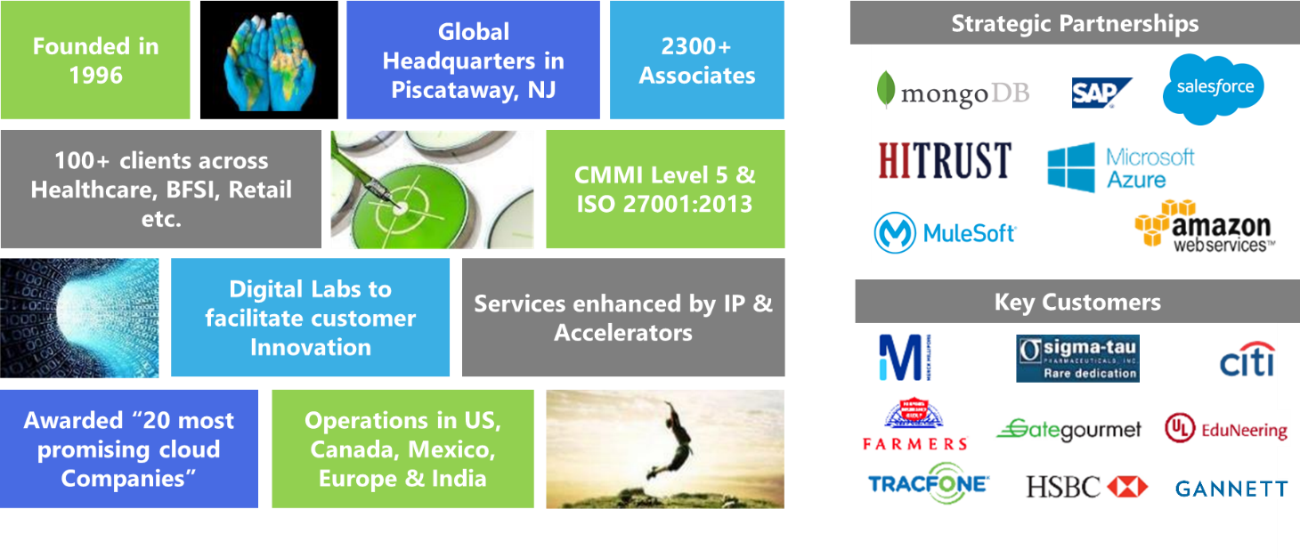Our Global Centers of Excellence (CoE) specialize in the areas of Cloud Computing, Mobile Technologies, BI-Analytics, Information Security, Java, Microsoft, and ERP Technologies. Through an emphasis on a quality system driven by CMMi, PCMM, ISO 9001-2000, ISO 27001 and SSAE 16 Type II best practices; and customer centric, transparent and well governed Client engagement model, Marlabs has achieved a dependable track record of meeting high standards of excellence in every customer engagement. This has resulted in several awards and recognitions, including being consistently ranked in the Deloitte Technology Fast 50 and Fast 500 programs.

**Marlabs Digital 360**

Businesses are moving to an Agile world that is integrated with DevOps. Marlabs enables you to streamline the entire product development life cycle to be on par with an ever-increasing demand for faster and quality product releases.

Our Transformation services include Strategic & end-to-end services and Focused services. We also provide training services to help your organization adapt easily to Agile and DevOps.

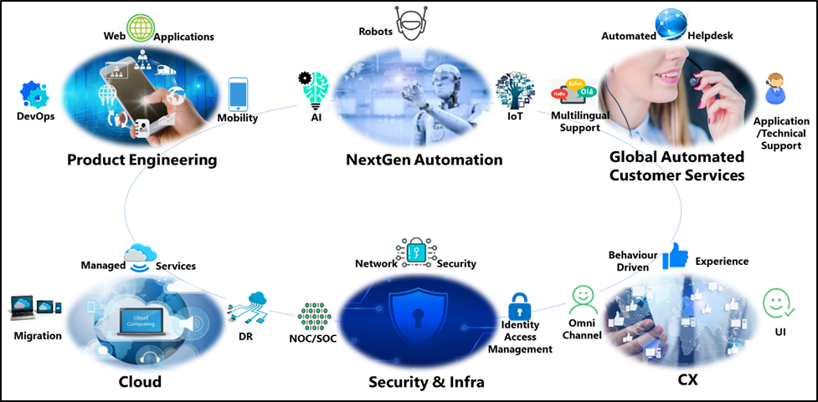

1. **Statement of how long the Proposer has been performing the services required by this RFP – in particular, supporting Clients that are Software Development companies**

**Answer:**

Post successful implementation of an automated testing project, Marlabs supports its customer on the short/long term maintenance work wherein Marlabs personnel are engaged in maintaining/upgrading the test automation framework, test scripts, writing newer test scripts, continuous execution and reporting.

1. **Location of headquarters, technical support, field offices**

**Answer:**

Headquartered in New Jersey, United States, Marlabs has a global footprint with offices and development centers across USA, Canada, Mexico and India, and strong partnerships with industry leaders, allows us to offer a wide range of IT services across industries. Marlabs team will be operating from Bangalore (India) as its Primary location and Kochi (India) as BCP location with robust network and voice connectivity. This will be achieved by integrating Marlabs and CBHS existing network and voice capabilities wherever feasible to provide a seamless end-user experience. Marlabs is also in the process of opening its offices in Darmstadt, Germany as its key European point of presence.

1. **Identify the location of the office which would service CBHS**

**Answer:**

Marlabs can provide services to CBHS at all locations across the globe leveraging our points of presence across regions. The delivery of this project shall be a mix of Offshore Onsite Model from New Jersey (US) / CBHS office & Mysore (India) respectively.

1. **Identify Proposer’s annual company revenues and profit for the last three company fiscal years**

**Answer:**

We are a privately held company and do not share financial information publicly. However, we can provide key financial metrics for the last 3 years to CBHS on request.

1. **Identification of any pending litigation against Proposer**

**Answer:**

Marlabs does not have policy to disclose any pending litigation against Proposer.

1. **Disclosure of any bankruptcy or insolvency proceedings in the last 10 years**

**Answer:**

Marlabs does not have any bankruptcy or Insolvency proceeding in the last 10 years.

1. COMPANY QUALIFICATIONS
2. **Describe the Proposer’s familiarity with Test Automation Frameworks and associated set-ups and integrations and experience with the requirements of a Software Development company.**

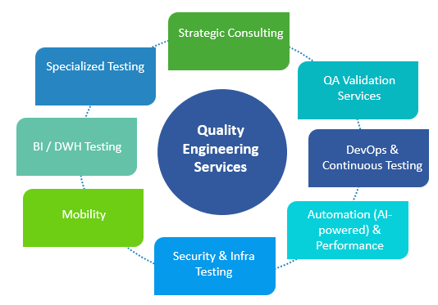**Answer:** Marlabs, being a Systems Integrator, has successfully helped numerous customers across various domains over the last 20 years implementing various projects with varying technologies. Marlabs Digital 360 framework as outlined in Section B above has breadth and depth of entire Software Development Life Cycle (SDLC) and Software Test Life Cycles (STLC) that integrates and validates various components of software product in order to meet the technical and business requirements.

Quality Engineering (QE) division is one of the practices of Marlabs that offers end to end testing services spanning across entire STLC / SDLC and offers specialized services in the test automation space. The following is a quick snapshot of various service offerings of Marlabs QE practice.

Marlabs Test Automation implementation approach, that’s shown below, is typically a step by step process to ensure well thought through, customized and successful implementation that often results in quicker ROI and minimal on-going maintenance.

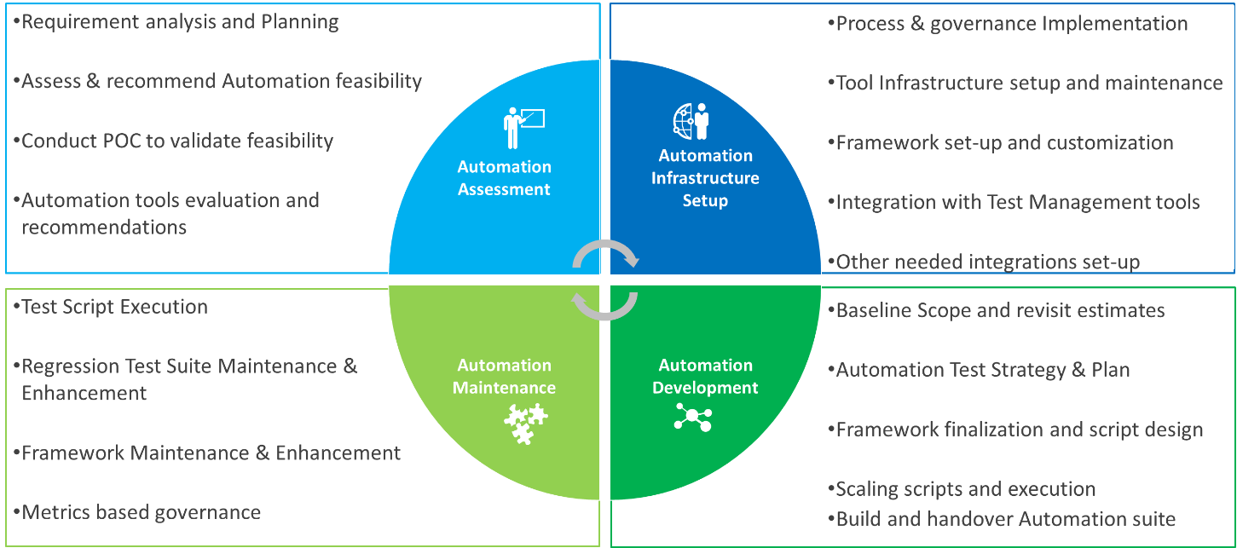

Marlabs has experience of working with numerous test automation tools from both commercial and open source spectrum and presented here is a snap shot that summarizes the same.

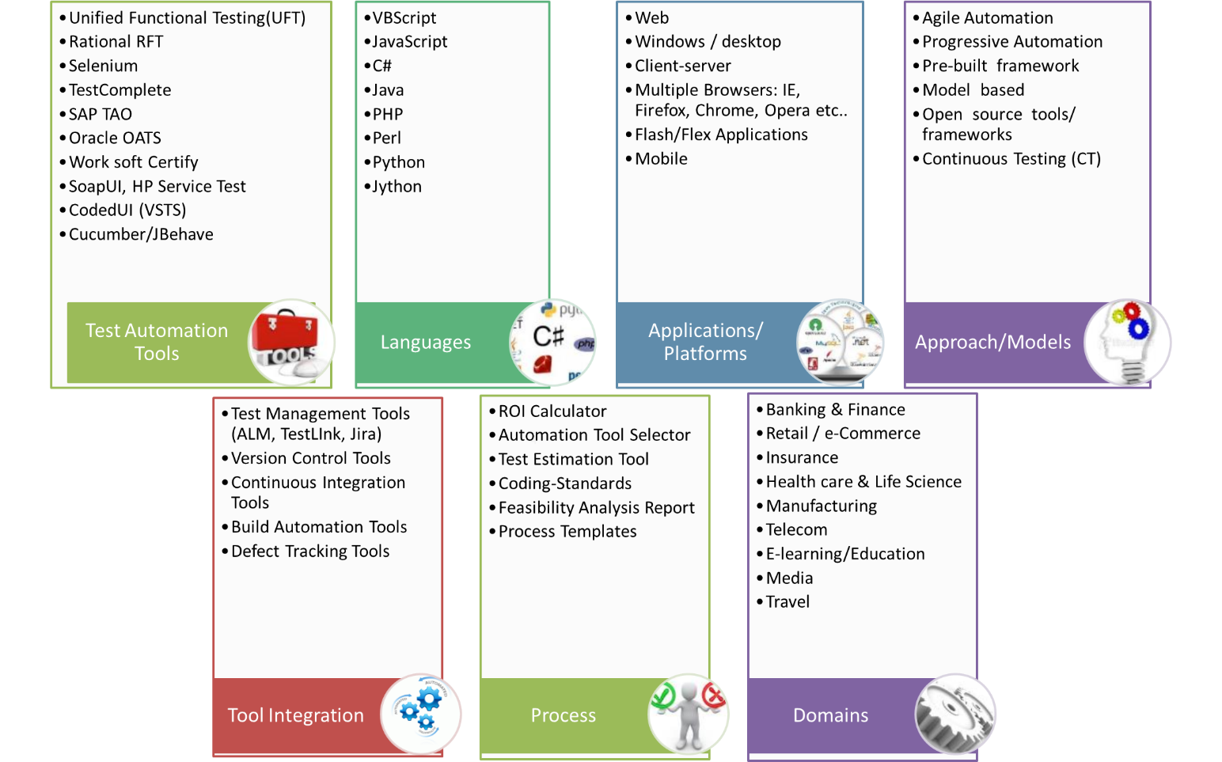

Marlabs has built proprietary test automation frameworks around prominent tools like HP/MicroFocus UFT, Microsoft Coded UI, IBM RFT, Selenium .etc. and such frameworks are usually a combination of data driven, key word, modular, page object model (POM) .etc. put together to take the best out of each and further customized specific to a given requirement. These frameworks ensure easiness of operation and maintenance, scalability, parallel execution, statistical and functional reporting and integration with test management tools like ALM-QC, MTM, Jira – QA add-ons. Below given is the architecture of one of such frameworks.

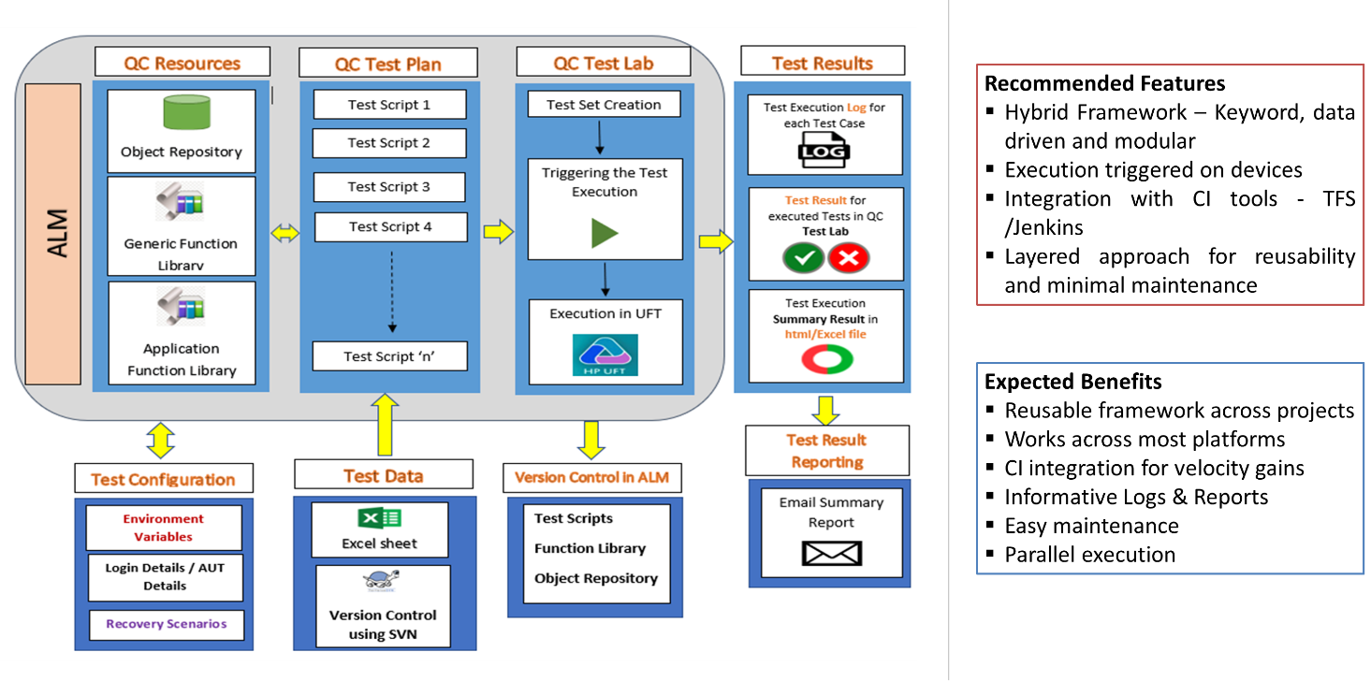

Marlabs test automation frameworks can be integrated easily with the Continuous Integration (CI) and Continuous Delivery / Deployment (CD) process and tools like Jenkins to ensure Continuous Testing. Shown below is the general approach of Marlabs DevOps integrating testing with various aspects of SDLC as an integral part of SDLC to ensure seamless testing and deployment of software application.

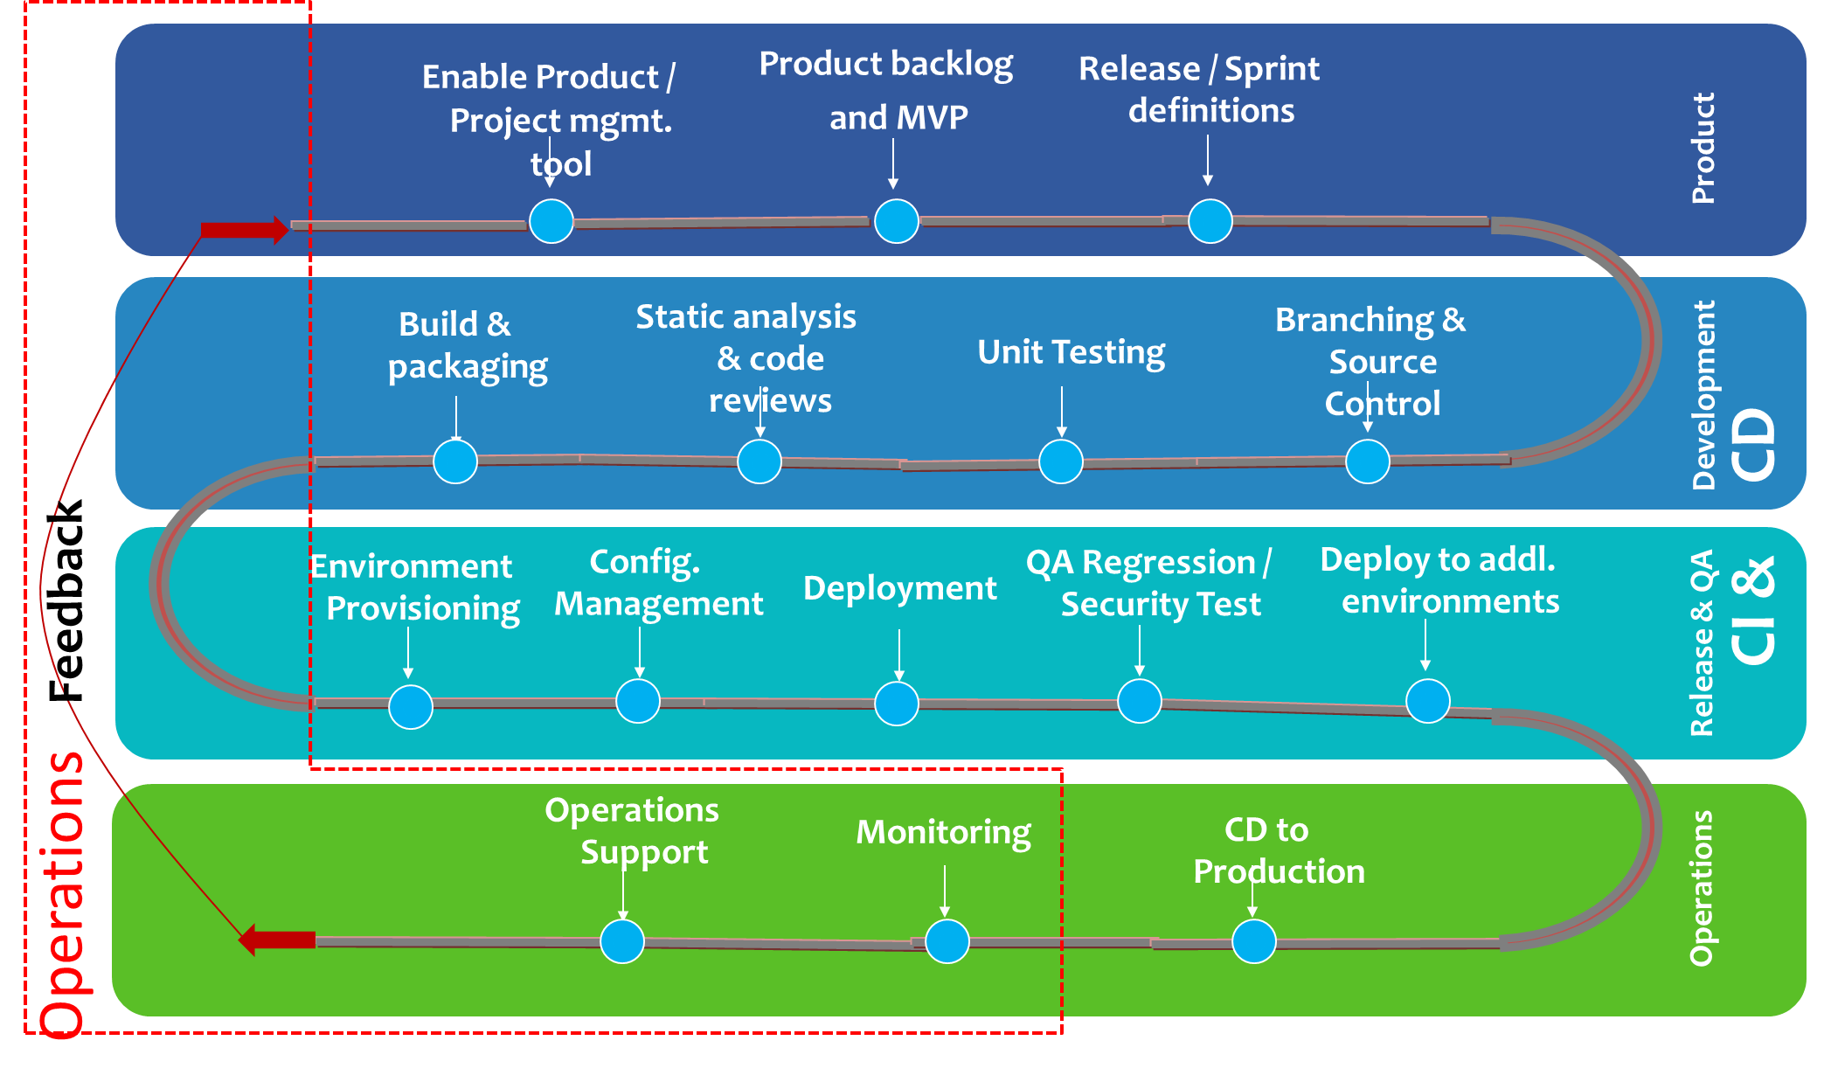

Marlabs is co-developing an AI powered test automation platform that revolutionizes the adoption of test automation in the SDLC phase aiming to minimize the test script creation time and on-going maintenance time while emphasizing and enabling the Shift left test approach. Below represented is a snapshot of where AI-driven automation would fit in the SDLC / STLC.

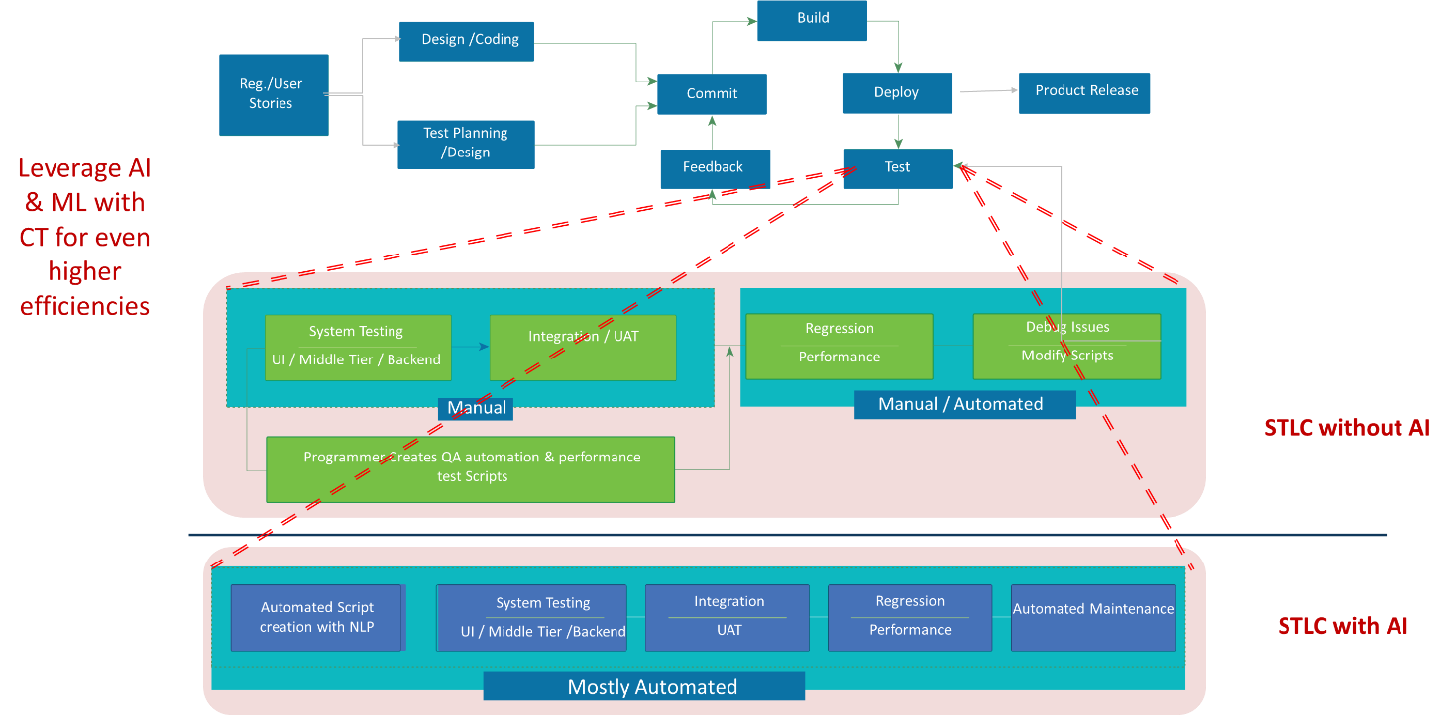

1. **Identify the Proposer’s existing Client base including the number of existing Clients using the solution being proposed**

**Answer:** Marlabs has more than 50+ customers any point where we offer one or more services of Quality Engineering practice and significant number of such customers leverage Marlabs for test automation services. Marlabs has the experience of working on various automation frameworks and tools as outlined in section 3.1 across various domains including Healthcare.

Marlabs has been actively working with development and testing of one of the top 3 EHR providers in the USA that includes test automation services to specific divisions of that organization. Pls, refer to Case Studies/References section for more details. In addition, Marlabs has experience of working with other EHR providers in various capacities and also with the Software Development & QA divisions of different healthcare organizations that leverage / implemented top EHR solutions.

1. REFERENCES

Marlabs agrees to provide Client references to some of our key Clients where we have successfully executed several Automation Testing Framework projects across the Globe.

|  |  |
| --- | --- |
| **Company, Address** | Our Client is a non-profit continuing legal education (CLE) organization chartered by the Regents of the University of the State of New York. Founded in 1933, the company organizes and provides CLE programs around the world. |
| **Contact name** | Will be shared on request |
| **Title** | Will be shared on request |
| **Contact Phone & email** | Will be shared on request |
| **Project Description including identifying the type of Test Automation Framework implemented** | **BUSINESS NEED**:   * Customer has major release every quarter and minor releases once a month with changes made to the existing applications constituting Web, Mobile and API’s. * Execution of the existing QA Regression cycle is manual and effort consuming, up to a week in most cases, for the QA team and such has a cascading impact on the new functionality that’s being built. * To save the effort on regression cycle customer wanted support from Marlabs to build a robust automation framework which is reliable, scalable and reusable, also integrate-able to VSTS built CI-CD release pipelines, supporting for Web, Mobile and API testing.   **MARLABS SOLUTION**:   * Marlabs performed a feasibility study on applications for automation and suggested tools which can support the web/mobile and API testing * Framework: Selenium C# combined with Coded UI for Web and desktop controls, Rest Sharp for API and Xamarin UI Test for Mobile were chosen over UFT, stand-alone Selenium, Appium and other tools. * Marlabs developed QA automation hybrid framework with defined coding standards, best practices, all the needed framework components from reporting, scalability and maintainability stand point along with triggering of automation test suite as part of the build & release pipelines in VSTS. * Integration of automation framework with JIRA-ZEPHYR test management add-on was also implemented as part of the framework.   **BENEFITS:**   * Stable and maintainable automation framework and automated regression scripts that runs quickly in just couple hours versus a week manually * Critical regression set (smoke test) runs on every build on nightly basis and the detailed regression set is executed on every release as part of the VSTS release pipeline. * Real time automation execution status displayed in Zephyr dashboard. * Xamarin UI Tests were executed as part of the CICD pipeline on Xamarin test cloud on the real devices, execution status was visible on Jira-Zephyr dashboard.   **Test Tools |** Automation Testing: Selenium C#, Microsoft Coded UI, Xamarin UI & C# Library for API automation.  **Test Management Tools |** JIRA-ZEPHYR  **DevOps Tools |** Visual Studio Team Services (VSTS) |
| **Implementation Timeline** | June 2016 till November 2017 |

|  |  |
| --- | --- |
| **Company, Address** | Our Client is a non-profit organization promoting international education and exchange of students who would be looking for internships and colleges programs in the USA |
| **Contact name** | Will be shared on request |
| **Title** | Will be shared on request |
| **Contact Phone & email** | Will be shared on request |
| **Project Description including identifying the type of Test Automation Framework implemented** | **BUSINESS NEED:**   * Customer was in the process of replacing a complex, highly integrated, cross functional administrative platform. * As features are released to production on frequent basis, the scale of quality assurance (including regression testing) became unmanageable for the project delivery team. * To ensure that the project team could stay focused on the project deliverables, customer opted for augmentative staff support with experience in automation testing from Marlabs.   **MARLABS SOLUTIONS:**   * Marlabs to provide guidance and expertise with building out customer’s test automation **framework** that uses Selenium with Protractor layered on top. This includes reviewing existing framework & automated test scripts and suggesting and helping to implement necessary changes & improved as per test automation best practices. * Create and maintain test automation scripts in support of customer’s ‘Beacon’ platform (and associated integrations) during this engagement. * Provide knowledge transfer and training of the test automation framework, script creation and test run steps to designated CIEE test automation resources.   **BENEFITS:**   1. Reduction of execution time of the Inbound Applications 2. Immediate health of build is obtained as the scripts are integrated with CICD 3. Framework is easily understandable and maintainable   **Test Tools |** Automation Testing : Selenium, Protractor, TypeScript (Java script conversion through VS-Code)  **Test Management Tools |** TFS  **DevOps Tools |** Visual Studio Team Services (VSTS) |
| **Implementation Timeline** | August 2017 – On going |

|  |  |
| --- | --- |
| **Company, Address** | One of the leading global provider of airline catering and provisioning services. With more than 70 years of experience in providing appealing food and beverage options, designed to fit any budget, that offers:   * A wide range of culinary solutions * "Last mile" provisioning to aircraft * Catering and provisioning services for non-airline business, such as airport lounges and convenience retailers |
| **Contact name** | Will be shared on request |
| **Title** | Will be shared on request |
| **Contact Phone & email** | Will be shared on request |
| **Project Description including identifying the type of Test Automation Framework implemented** | **BUSINESS NEED**:  Customer was having requirement for independent testing and validation services for their product line: Inflight Exchange (IFX), PAC Plus, POPS, Customer Portal, Total Solutions that should include end to end QA offerings both manual and automated fashion.  **MARLABS SOLUTION:**  Marlabs conducts following testing activities to manage the quality assurance of all products listed   * Functional testing: sprint-based execution * Automation testing using Appium and Selenium tools for iOS native App, and Katalon Studio (Selenium wrapper) for web applications. * Sanity Testing * Regression Testing – both manual and automation * API testing using Swagger * DB testing on each release sprints * Performance Testing on most releases * Mobile Testing * Web Service Testing using Soap UI tool   **BENEFITS:**   1. Reduction of execution time of the Inbound Applications 2. Framework is easily understandable and maintainable 3. End to end services   **Test Tools |** Automation Testing: Selenium, Katalon Studio, Appium, SOAP UI, Swagger; Performance Testing: NeoLoad  **Test Management Tools |** Jira |
| **Implementation Timeline** | On-going for over 6+ years |

|  |  |
| --- | --- |
| **Company, Address** | One of the leading American supplier of [health information technology](https://en.wikipedia.org/wiki/Health_information_technology) (HIT) solutions, services, devices and hardware. As of February 2018, its products were in use at more than 27,000 facilities around the world and recognized as one of the top EHR’s. Customer applications are developed with physicians in mind, so they can focus on people and not technology, And providers can manage their day-to-day revenue functions with the integrated clinical and financial systems. |
| **Contact name** | Will be shared on request. |
| **Title** | Will be shared on request. |
| **Contact Phone & email** | Will be shared on request. |
| **Project Description including identifying the type of Test Automation Framework implemented** | **BUSINESS NEED:**   * Customer was looking for an extended Systems Integrator to meet the product feature backlog in terms of developing and testing various portions of their own EHR and their acquired product from another company in terms of integrations between two and overall workflow. * Customer was looking for efficiencies and productivity through tools and automation wherever possible across the systems.   **MARLABS SOLUTION:**   * Specific to QA portion, Marlabs carry out the following activities on each sprint and/or release pertaining to different modules like Power Charts, Supply Chain workflows, Pharmacy, Surginet, Clinical, AMS, UI, Accessibility, PathGet, Pulmonary, Patient records and Outpatient Nursing. Marlabs team is also involved with UI conversion projects :   + Functional test case design and execution   + Test Planning and Strategy   + Regression testing in both manual and automated fashion   + DB testing and API testing   **BENEFITS:**   * Able to Maintain 508 compliance. * Independent teams catering to the needs of a given project and/or division * Frameworks are integrate-able to respective divisions tools sets. For example, real time automation execution status displayed in test case management tools   **Test Tools |** Automation Testing: Hankins, GitHub, ALM testing tool, eggplant for image-based system validations, API automation through custom built wrappers, Selenium web driver for UI/web portions  **Test Management Tools |** JIRA, ALM-QC |
| **Implementation Timeline** | Over 2 years |

1. PROPOSED SOLUTION
2. **Provide a brief solution overview identifying the components of the Test Automation Framework and needed integrations**

**Answer:**

Marlabs understands that CBHS is going through a Quality Engineering transformation to position IT to deliver maximum value and quality to business initiatives and at the same time, be futuristic in all of today’s decisions. The RFP is focused on building a strong foundation as part of CBHS Quality Engineering transformation goal. Marlabs solution proposed for this RFP recognizes this need for current & future and provides the solid foundation in building the initial framework, tools, and the regression suite.

Based on the understanding from proposal and our wide experience in Quality Engineering services, Marlabs proposes two solution options to CBHS. They are as follows:

1. Traditional automation solution based on the renowned Selenium Automation framework
2. Futuristic AI based automation solution using AutonomIQ, a co-developed platform by Marlabs and AutonomIQ

While both solutions are equally best in class and are implemented and running successfully, traditional automation has been there for a while in the industry while AI based is relatively new yet provides the greatest value with significant cost savings. We shall review & analyze both the frameworks in subsequent sections below.

## Option 1: Test Automation Framework built using Selenium C# & Microsoft Coded UI

While Selenium is best known in the industry for automating web applications, it has limitations when it comes to handling windows related controls and applications. On the other hand, coded UI is a powerful automation tools from Microsoft for web and desktop/windows applications, but it has limitations when it comes to handling multi-browser execution. Hence our recommended solution combines the best of both addressing web controls and cross browser execution through Selenium while handling windows/desktop controls through Coded UI.

It’s a hybrid framework that’s modularized and consists of various layers as follows:

1. **Input layer**
2. Object layer (Structured in a page object model)
3. Keyword and data script
4. Data Layer
5. **Framework Layer**
6. Framework engine & Controller
7. Generic functions
8. Business functions
9. Application specific functions
10. **Output layer**
11. Cross browser execution
12. Custom reporting

Following is an Illustration of the Selenium & Coded UI framework:

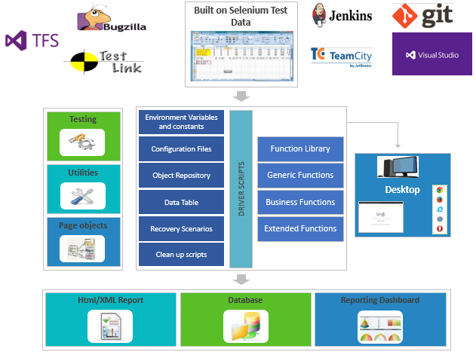

**Highlights:**

1. Hybrid Framework – a combination of Keyword, data-driven and modular framework is used to build this framework
2. Config file(s) as a driver: a simple config file can be used to control the parameters of test execution
3. Execution can be triggered from multiple VM’s with multiple formats for results – HTML / XML. This can reduce the execution time of the automation suite.
4. A layered approach for reusability and minimal maintenance
5. Integrated with TFS/git for version control
6. Continuous Integration using Microsoft build tools/Jenkins
7. Logical separation of Test cases & Test Data
8. Easily Portable: The framework can be deployed in any VM & physical machines
9. Extensible with Protractor and Dot-Net-Appium when required

**Expected Benefits to CBHS:**

1. C# based Code UI tests: As CBHS uses Microsoft technologies, the C# based Code UI tests will be an added advantage in terms of object recognitions & corresponding actions, automation maintenance by CBHS and also during project transition.
2. Ability to address web and windows controls and enable execution at scale across browsers
3. Reusable framework across projects: Other project teams can decide to use the framework from a common location or can copy for use in other projects. The framework, Generic functions as well as the integrations remains active and can be reused across projects.
4. Execution flexibility with a Modular Structure: The test scripts are grouped by feature/ modules with independent scripts for each test case. Test Scripts can be executed in group or suite or assorted manner. The test cases to be executed can also be filtered and sorted. It also supports cross-browser execution.
5. Easy Maintenance: Our framework uses a Page Object Model (POM) design. Here, UI Objects are defined in Repository by Web Page allowing automation testers (CBHS/ Marlabs) to correct page object properties in one place, though it is used by many functions/test scripts.
6. Detailed Reporting: Two levels of reporting is available in the framework. The parent level report provides a summary of the test execution with reference to the test cases selected for execution whereas a detailed report is available against each executed test case, helping user to quickly narrow the location of failure, reason for the failure, details of the verification performed in each step & screenshots.
7. Failure Debugging: The informative logs provide the technical aspects of the error whereas the detailed execution report provides functional aspects of the error. The later provides comparison between the expected and the actual values leading to the error. Also, the ability to capture screenshot on failures
8. Integration with Version Control/ Code Repository tools such as TFS, git & CI-CD tools such as Jenkins, VSTS.
9. Extensibility: This framework can be extended to mobile testing with Appium packages. It can also be further customized to any other requirements that are typically viable in the automation space.
10. Scalability: As test cases to be executed are picked up from queue, the number of test cases to execute does not matter. If more execution VMs are used, then the execution time can be cut down significantly.
11. Transition & Training: Though the framework has multiple capabilities, it is simple for automation testers or developers to understand after a quick training. Marlabs shall also create documentations on the framework and its usage.
12. Execution Proof: Screen shot capture on failed cases, if not on all steps

**Note:** Although Selenium does take care of automation of Angular applications, Protractor is well known in the Angular space. However, the primary language bindings from Protractor are JavaScript (JS) based. There are customer wrappers developed by various developers in the open source community, and as needed, Marlabs shall extend the above solution with such customer wrappers for additional reliability. Marlabs does have very similar solution built on Protractor JS as outlined in the second case study earlier in this document.

## Option 2: Futuristic AI based automation solution using AutonomIQ

Marlabs AI based Test Automation solution powered by AutonomIQ is test automation platform that enables business and IT teams to automate rapidly along the lines of iterative release and deploy of software, thereby increasing the velocity of software releases without compromising quality. With its in-built NLP engine, users can instantly create test automation scripts from plain English test cases with detailed steps. It also generates associated test data, execute tests serially or in parallel and much more. Using deep-learning and AI algorithms, AutonomIQ detects changes, enables self-healing for test assets and provides advanced diagnostics. In real world situations, AutonomIQ has been shown to provide over ~50% improvement in speed and quality compared to existing tools and techniques. With Selenium being the underlying engine, this platform is expected to work with any web / SaaS application with no support for desktop/windows objects/apps at this point. Below is the overview of the platform:

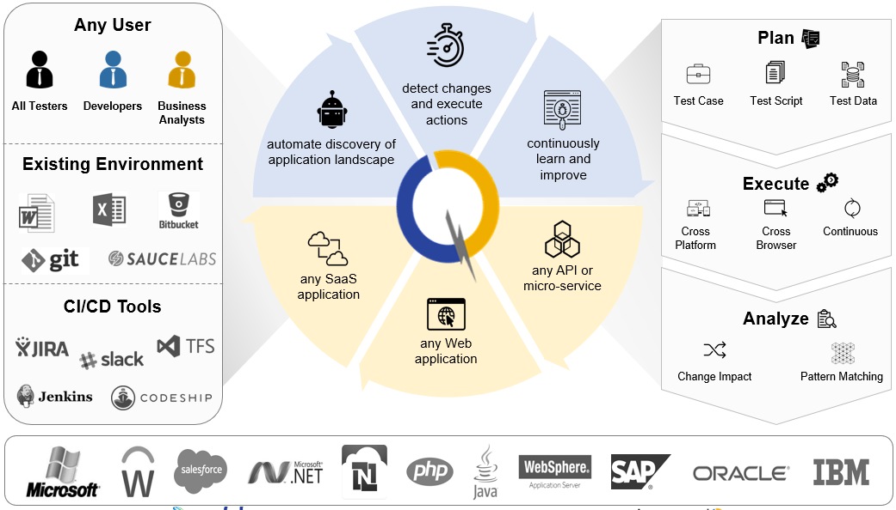

**Highlights of the platform:**

* With built-in AI-NLP, Automated test script generation from an English test case written in plain human readable form
* With built-in NLP and user actions recorder, ability to create English test cases as the manual tester/BA interacts with the application under test
* Data driven testing/Ability to perform same set of actions repeatedly with numerous rows of data
* Autonomous test script maintenance in case of application changes that results in automation identifier changes
* Point-in-focus screenshot capture on each step execution
* Automatic handling of various technology related objects
* Integration with CI/CD tools for execution triggering on builds and/or autonomous updates
* Ability to invoke User Defined Functions

**Expected Benefits to CBHS:**

1. Quicker on-boarding with significant savings
2. Framework less approach yet customizable features in terms of integrations
3. Execution flexibility: Selective or all test cases can be executed either on scheduled or on-demand basis
4. Easy Maintenance: Except for new functionality related changes and business logic related changes, object level changes to existing test cases are usually taken care automatically
5. Detailed Reporting: Both summary and individual test case level reporting
6. Failure Debugging with screenshots and/or video created out of execution
7. Integration with Version Control/ Code Repository tools such as TFS, git & CI-CD tools such as Jenkins, VSTS.
8. Scalability: As test cases to be executed are picked up from queue, the number of test cases to execute does not matter. If more execution VMs are used, then the execution time can be cut down significantly.
9. Easier training in terms of usage.
10. IMPLEMENTATION APPROACH AND WORK PLAN
11. **Identify any additional services or components that were not identified in RFP Section 4 but that the Proposer recommends that CBHS considers. Include a description of the services and components that are being recommended**

**Answer:** With the primary goal of any automation project, in general, is to increase quality while shortening the execution time, Marlabs proposes the following additional services to further improve the quality of the application:

1. **Test Data Management**: The success of the automation testing is dependent on various factors like coverage, scenario selection, reliability and maintainability of the framework .etc., the core important feature that business teams would worry about is the usage of right test data. It is important that we feed in the right data that would uncover right defects and, in most cases, the data being used should be close to what’s done in the production. Here are some test data management strategies:
2. **Performance Testing:** While automation testing uncovers defects specific to functional aspects of the system, performance testing uncovers defects specific to non-functional aspects such as reliability, scalability .etc. In order to attain and maintain the desired quality of software, it is important to carry out the following performance tests:
   * **Load Testing**: Application under test is subjected to different levels (low, normal and high) of load
   * **Stress Testing**: To determine the breaking point of the application under test
   * **Endurance Testing**: The stability of application is examined by testing for an extended period
   * **Spike Testing**: The Impact of a sudden increase in load during abnormal conditions is examined
   * **Scalability Testing**: To determine the scalability of the application under test for the target Load
   * **Volume Testing**: To test the performance of the application at high volumes of data
   * **Batch Performance testing**: Monitor the various application parameters during the batch process execution and identify performance bottlenecks – during deployment / other batches.
   * **Benchmark Testing:** Process of load testing a component or an entire end to end IT system to determine the performance characteristics of the application.
3. To further improve the quality of software, Static & Dynamic analysis, thorough and extensive unit tests (automated unit tests) would be desirable.
4. **Provide a project organization chart highlighting the key staff who will be assigned to the project. Provide biographies for the key assigned resources.**

**Answer:**

Following is a quick snapshot of the project organization chart.

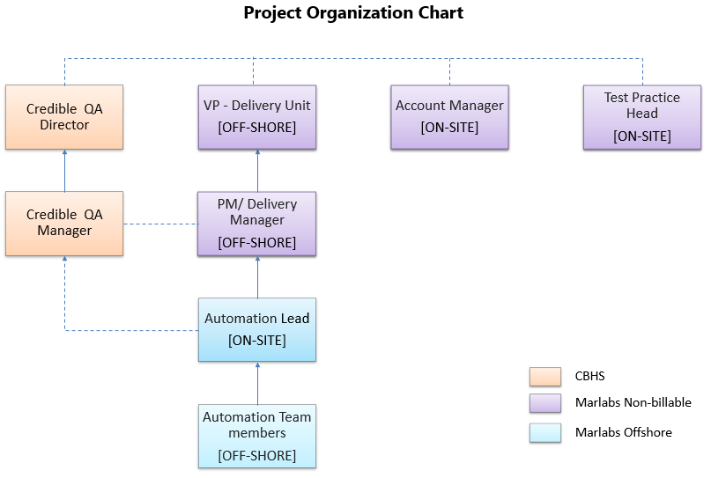

Sample Biographies for the key assigned resources are attached



1. **Describe the roles and responsibilities of CBHS staff during implementation and provide an estimated number of CBHS resources, expected role and level of effort during each phase of the project.**

**Answer:**

Marlabs approaches this engagement as outlined below. Marlabs stands by the below milestones set by CBHS as part of delivery of this project.

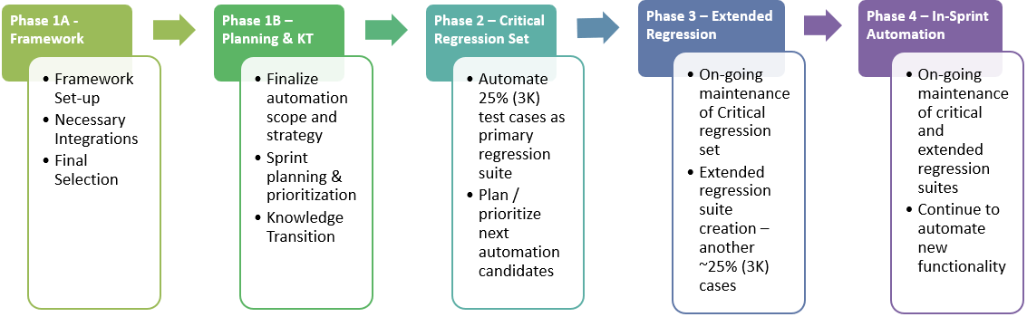

Right at the end of Phase when the critical regression suite is automated, Marlabs recommends having two automation teams - one to automate extended regression suite and another team to automate the current and on-going functionality in a spring delay fashion. During Phase 4, Marlabs recommends switching to in-sprint methodology.

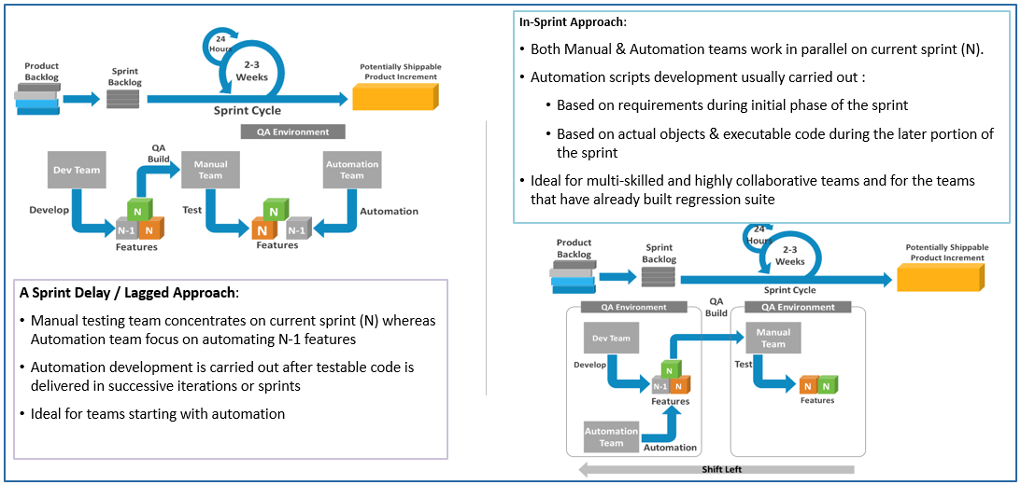

In addition, Marlabs recommends the following activities for efficient use of this model.

**Phase 1A | Framework Finalization | Duration 0-1 month**

1. **CBHS Milestones:**
   * Work with Marlabs to finalize the tool and framework features
   * Finalize configuration and set-up.
2. **Additional suggestions:**
   * Project kick-off meeting with all stakeholders
   * Take stock of test artifacts & documentation, including list of manual test cases
   * Prepare & execute knowledge transition plan
   * Demo & gather automation framework customization requirements
   * Implement automation framework customization requirements
3. **Deliverables:**
   * Project kick-off meeting minutes
   * Knowledge transition completed
   * Framework customization & configuration completed
4. **CBHS Resource Commitment:**
   * 25% of QA manager time for planning sessions and review of framework

**Phase 1B | Automation Planning & Knowledge Transition| Duration : 2 to 4 weeks**

1. **CBHS Milestones:**
   * Identify and agree on automation scope and strategy
   * Knowledge Transition
2. **Additional suggestions:**
   * Manually execute priority test cases from vital modules post transition
   * Identify critical set test cases for automation
   * Plan for Phase 2. Identify critical test cases for automation, roughly 25% (3K test cases), referred to as Critical regression set.
   * Prioritization of automation candidates for Sprint planning
   * Sprint Planning for Sprint 1.
   * Estimate the duration of the automation
3. **Deliverables:**
   * Approved automation strategy/ plan
   * List of Critical regression set test cases
   * Automation candidates finalized & prioritized
   * Complete manual execution of test cases
   * Automation candidates for Sprint 1 finalized
   * Manually executed priority test cases
4. **CBHS Resource Commitment:**
   * 20% of QA manager time for planning sessions
   * 50% of SME time for about 2 weeks

**Phase 2 | Critical Regression Set Automation | Duration: 2 weeks sprint; recur until backlog consumed**

1. **CBHS Milestones:**
   * Test cases’ automation will be organized in a two-week sprint.
2. **Additional suggestions:**
   * Automate Critical set test cases in 2 weeks sprint
   * Subsequent sprint planning
   * Identify extended regression set which includes next 25% critical test cases (3K test cases)
3. **Deliverables:**
   * Critical set test cases automated
   * Sprint Retrospective for feedback & Corrective actions for subsequent sprints
   * List of Extended regression set test cases
4. **CBHS Resource Commitment:**
   * 20% of SME time to review test case and script artifacts

**Phase 3 | Extended Set Regression Automation | Duration: 2 weeks sprint; recur until backlog consumed**

1. **CBHS Milestones:**
   * Test cases’ automation will be organized in a two-week sprint.
2. **Additional suggestions:**
   * Automate Extended set test cases in 2 weeks sprint
   * Subsequent sprint planning
   * Identify & fix Critical regression set scripts which require maintenance
3. **Deliverables:**
   * Extended set test cases automated
   * Sprint Retrospective for feedback & Corrective actions for subsequent sprints
4. **CBHS Resource Commitment:**
   * 20% of SME time to review test case and script artifacts

**Phase 4 | In-sprint Automation & Maintenance| Duration: 2 weeks sprint; recur until backlog consumed**

1. **CBHS Milestones:**
   * Not notified
2. **Additional suggestions from Marlabs:**
   * Identify & fix Critical & Extended regression set scripts which require maintenance
   * Test scripts failing due non-application issues will be investigated and fixed.
   * During this phase, Marlabs team will be updating the automated regression suite to accommodate changes in applications due to ongoing releases.
   * Marlabs team will collaboratively work Security place to understand new features planned for current releases across each application.
   * Marlabs proposes to use in-sprint methodology if situation permits during this period.
   * Marlabs team will keep the automated regression suite up-to-date across applications.
3. **Deliverables:**
   * Test script up-to-date or part of planned maintenance plan.
   * New functionalities automated within the same sprint

In the event, PMO /QA team chooses to do the maintenance on their own, Marlabs will do the complete transition to enable them for self-sustenance.

**Work Plan**

The detailed Work Plan is described below. This plan is arrived with various assumptions around number of test cases and their complexities and with specific tool sets in mind. These plans are subjected to change and firmed-up during Phase 1A & 1B as Marlabs gain better understanding of the entire landscape of CBHS.

**Option 1 – Traditional Automation Approach**



**Option 2 – AI Based Automation**

1. **Explain Marlabs Sprint approach**

From phase 2 onwards, the project will be executed in an agile sprint-based model. Typical duration of the sprint being 2 weeks with initial sprints focusing on creating project specific re-usable methods and each sprint is expected to deliver working scripts on an incremental fashion.

In order to ensure that the test cases are thoroughly written for automation teams consumption, automation team will spend a day or two at the beginning of the given sprint (N) to thoroughly evaluate and re-write any needed test steps and/or test cases of the following sprint (N+1) so that CBHS QA team would get 8 more days in the given sprint (N) to review and sign-off on the modified cases. Following image depicts the common Automation Activities performed during a sprint cycle:

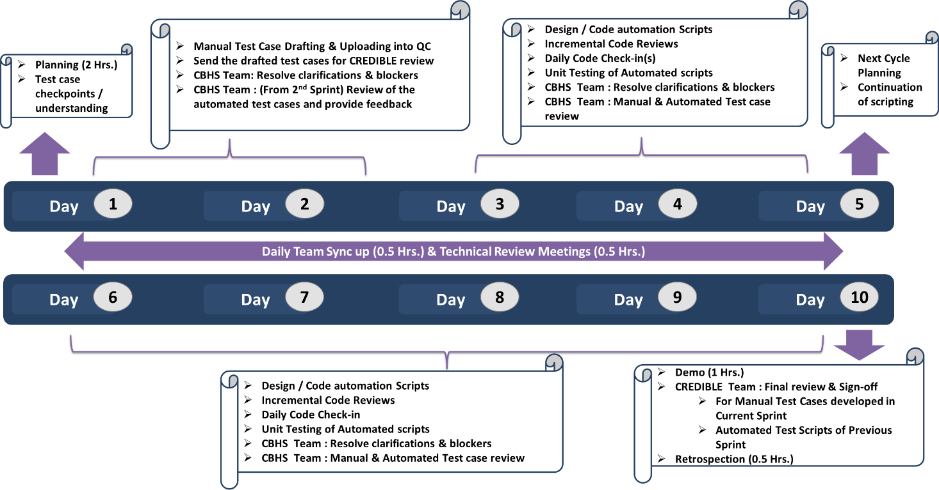

1. **Project Management & Governance Model**

A clear communications plan will be defined during the Initiation stage of the project. Some of the key communication components that Marlabs intends to use are shown below.

Regular meetings shall be held at various levels to report project progress. Marlabs proposes the following meetings for this project:

| **Type of Communication** | **Communication Schedule / Frequency** | **Communication Mechanism (email/meeting)** | **Who Initiates** | **Recipient** |
| --- | --- | --- | --- | --- |
| **Defect/problem/**  **Issue/action items** | As Needed | * Email/ Teleconference | * Automation Lead | * CBHS PM * CBHS Testing Team |
| **Status Report** | Weekly | * Email | * Automation Lead | * CBHS QA Manager * Marlabs Project/ Delivery Manager * Marlabs Account Manager |

Below is the proposed Governance Model for this engagement at CBHS

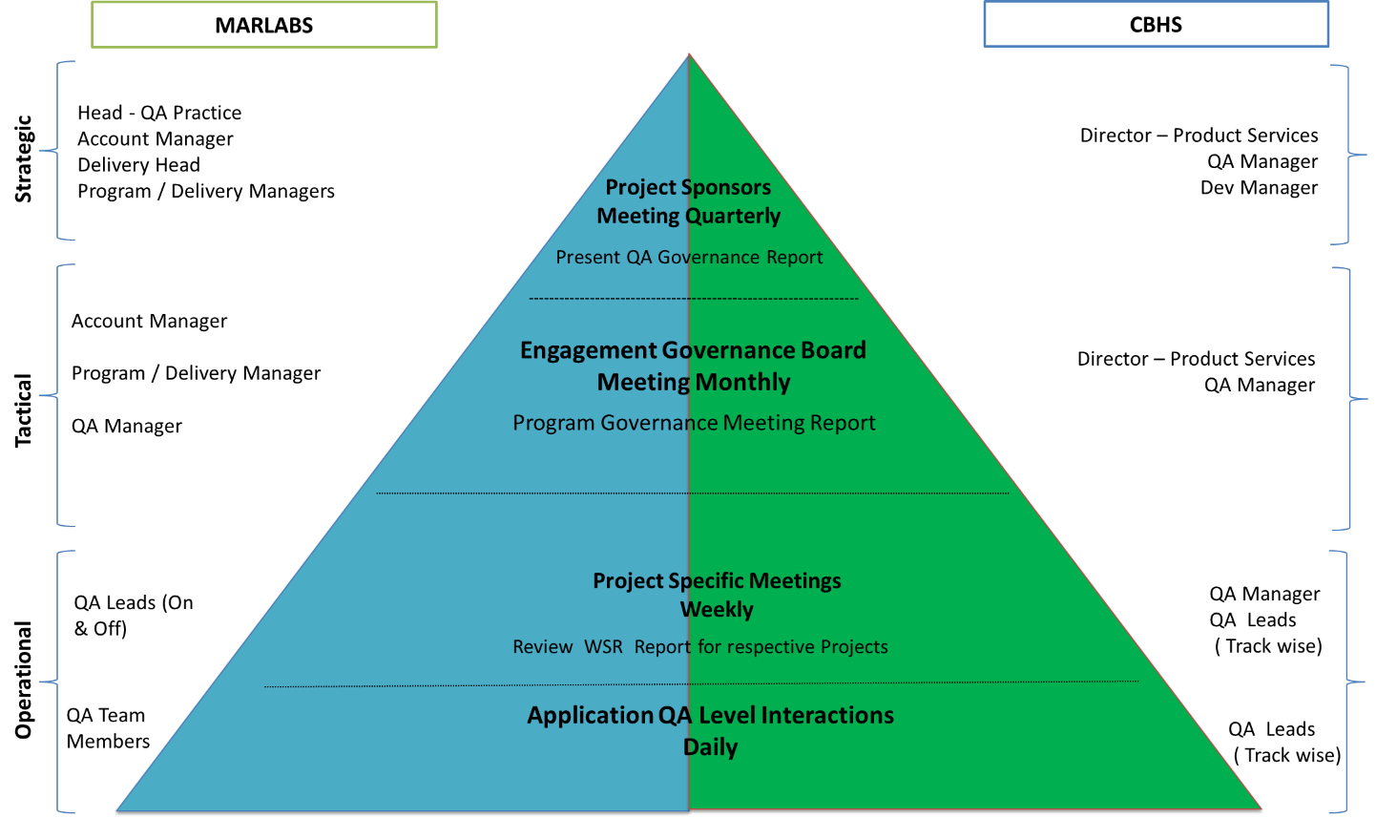

1. ASSUMPTIONS
2. Marlabs expects CBHS to appoint a Single Point of Contact (SPOC) for the proposed engagement for clarifications and approvals that may be required from time to time.
3. All the application content, system documentation, screen layouts & position of screen controls will be provided by CBHS.
4. CBHS to procure and provide a license of any 3rd party tool for Solution option 1 once the tool sets are finalized.
5. Marlabs testing team shall be provided with all required remote access by CBHS to the onsite environment to undertake development/testing activities.
6. All the required access rights shall be provided CBHS.
7. All hardware specification documents and hardware samples that may be required for the solution implementation will be procured and provided by CBHS – with both the solution options.
8. Software development related documentation, if any, excluding the functional specifications not mentioned here, will be made available by CBHS.
9. Technical documentation and access for linking to third party applications if any will be made available by CBHS.
10. Be responsible for timely acceptance of all deliverables so as not to impact the development schedule of the project.
11. CBHS is expected to approve the various project documents and deliverables submitted within 3 days of submission, during the different phase project execution. Any delay in the completion of this activity may impact the project schedule and cost.
12. Manual Test cases will be made up-to-date by CBHS QA team and Marlabs shall use such base-lined cases for test automation
13. Manual Test cases of automation candidates are up-to-date and available in the previous sprint (n-1) for sprint planning
14. All the estimates, pricing, and duration are provided based on assumptions that we have about 12,000 cases and about 25% will part of initial regression scope, and another 25% as extended set. Each set will be of about 3000 test cases with 35% simple, 50% medium and 15% high complexity where the complexity is defined as
    1. Simple: Anything less than 10 steps and/or 3 to 5 validation points
    2. Medium: 11< number of navigation steps >=20 steps and/or 6 to 7 validations points
    3. High: 21< number of navigation steps >=25 steps and/or 10 validations points
15. PRICING

## Pricing Proposal

Marlabs wishes to execute this engagement on a T&M basis, however, with the assumptions indicated earlier, the estimated cost of undertaking this engagement for CBHS is as given below:

**Option 1 – Traditional Automation**



**Team Considered:**

|  |  |  |  |
| --- | --- | --- | --- |
| **Role** | **Number of Resources** | **Bill Rate (/Hr)** | **Location** |
| QA Automation Lead | 1 | $95 | Onsite – CBHS Office |
| Sr. QA Automation Engineer | 3 (2 in Phase 1) | $26 | Marlabs – India |
| QA Automation Engineer | 2 (0 in Phase 1) | $24 | Marlabs - India |

**Option 2 – AI Based Automation**



**Team Considered:**

|  |  |  |  |
| --- | --- | --- | --- |
| **Role** | **Number of Resources** | **Bill Rate (/Hr)** | **Location** |
| QA Automation Lead | 1 | $95 | Onsite – CBHS Office |
| Sr. QA Automation Engineer | 2 (1 in Phase 1) | $26 | Marlabs – India |
| QA Automation Engineer | 2 (0 in Phase 1) | $24 | Marlabs – India |
| Automation Modeling Engineer | 1 | $40 | Marlabs - India |

**Additional Consideration:**

This platform can either be installed on-prem or can be accessed as SaaS. With On-prem version, CBHS is expected to procure necessary hardware needed whereas license cost indicated above for SaaS is inclusive of hardware costs too.

## Terms & Conditions

1. The invoicing & payment milestone shall be discussed during the finalization of the SOW.
2. The charges do not include any local taxes and levies, which will be extra as applicable.
3. Any additional project-related travel required by CBHS will be billed separately, at actual. No such billing will be made without the prior approval of Mathematica Office.
4. Payments need to be made within 15 days from date of the Invoice.
5. All pricing given above is valid for a period for 30 days.
6. SOFTWARE SUBSCRIPTION AND SUPPORT AGREEMENT

With the first solution option of traditional approach of automation with Selenium/protractor, Marlabs does not have any subscription model or IP. Marlabs deploys the entire code on-premises and CBHS will own the rights of the same at the end of the engagement.

With the second solution option of Marlabs AI based solution powered by AutonomIQ, Marlabs does have a user based monthly subscription model with 2yrs commitment, to begin with, and such commitment starts from the beginning of Phase 2. Support/end user licensing agreement is attached for reference.

Hardware Specs for AI Based Solution:

* For Server set-up: Linux server with Docker support of 17.6+ with 2 cores on Vmware VSphere, 4 cores in Hypervisor and with minimum hard disk space - 150 GB & Minimum of 16 GB RAM
* For run time machines: Linux preferred but Windows as well with 8GB Ram, standard CPU, and the of VMs can be as many tests as you want to run in parallel.

Platform can be deployed as a docker swarm or kubernetes over multiple VMs. If setup as a cluster, test execution can concurrently run tests across many browsers and Operating Systems. For example, we can support parallel execution of tests on Chrome 69, 70 on Red Hat Linux, Windows 7 and Windows 10.



1. CONFIDENTIALITY INFORMATION

During the term of this Agreement, either party may receive or have access to technical information, as well as information about product plans and strategies, promotions, customers and related non-technical business information, which the disclosing party considers to be confidential ("Confidential Information"). Before such Confidential Information is disclosed, the parties will first agree to disclose and receive such information in confidence. If then disclosed, the Confidential Information will be marked as confidential at the time of disclosure, or if disclosed orally but stated to be confidential, will be designated as confidential in writing by the disclosing party summarizing the Confidential Information disclosed and sent to the receiving party within 30 days after such oral disclosure.

Confidential Information may be used by the receiving party only with respect to the performance of its obligations under this Agreement, and only by those employees of the receiving party and its subcontractors who have a need to know such information for purposes related to this Agreement, provided that such subcontractors have signed separate agreements containing substantially similar confidentiality provisions. The receiving party will protect the Confidential Information of the disclosing party by using the same degree of care (but not less than a reasonable degree of care) to prevent the unauthorized use, dissemination or publication of such Confidential Information, as the receiving party uses to protect its own confidential information of like nature. The receiving party's obligation under this Section will be for a period of three (3) years after the date of disclosure.